IoT Based HOME AUTOMATION

BY

Nischal M

Md. Sarfraz Siddiqui

Namitha Suresh

Prateek Mohta

Aishwarya B

Bhavya L

Prakruthi B K

Monisha C

**TABLE OF CONTENTS**

1. Introduction

* Purpose
* Significance and justification

1. Research objective and assumption of the study
2. Definition of terms and concepts
3. Literature review
4. Design
5. Results/ Findings
6. Conclusion
7. References
8. Appendix

**INTRODUCTION**

**PURPOSE**

Home automation is a wireless system which is considered as our future requisite. It consists of ­­­lighting, HVAC, security. As home automation is interoperable it helps us manage our device anywhere outside and inside the house. With Internet of Things(IoT), the Home automation systems can wirelessly connect to the internet and exchange and management of data can be done on the cloud. Since, the Home automation system & Internet require a gateway for operation of the system, it becomes vital to provide a secure network layer for the system. Various layers of network are employed between the home systems(sensors, appliances) and the internet(cloud) and that makes the system vulnerable to cyber attacks and cumbersome to develop or upgrade the existing system.

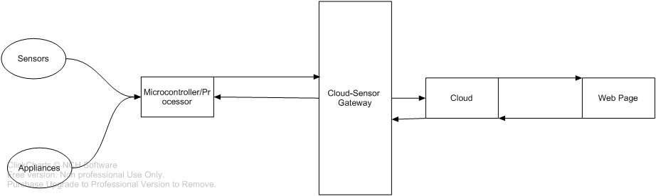

Conventional interface between sensors and cloud

This project aims at designing a IoT based home automation system with reduced layers of networks and better integration between the sensors and the cloud, so that the data can be securely exchanged, managed and monitored.

**SIGNIFICANCE AND JUSTIFICATION**

Working outside is always not a satisfactory experience. Most of the works have shown successful results when performed in a place with tranquillity and it also gives relief to know that the important files, documents are safe in our home-office. Most of the homes have made it mandatory allocation for smart office. As it contains intelligent lights, smart fan, automated fire alarm and RFID based security system. Totally it’s an office space with new technology and holistic long term perspective.

Major benefit of smart home to consumers is energy management through lighting and home appliances.. Energy management can be done by keeping track on the usage of appliance. There are many companies working on home automation and this is a field where innovation is going on from the year 1975. Its current value is $5.77 billion in US and is predicted to be over $10 billion by the year 2020. Surely home automation has come here to stay and making it more reliable to consumers will elongate its longitivity and makes our life a better place to live.

A common problem associated with IoT based Home Automation is the connectivity of sensors and appliances with the cloud. Since it’s important for devices to communicate with each other, exchange of sensor data usually has a gateway to connect them to the internet. Different sensors use different communication protocol & sometimes it is cumbersome connecting different sensors to the cloud. Reducing various layers of network module and giving the data to the cloud in reduced steps will enhance the security of the system, improve synchronisation of data, make the design of system compact and ease the connection of additional components to the system.

**RESEARCH OBJECTIVE**

The research objective of this project is to design an IoT based Home Automation which has a secure layer of communication. Since, the conventional way of sending data to cloud includes various gateways, the objective of the project is to reduce the layers of network between the appliances/sensors.

**DEFINITION OF TERMS AND CONCEPTS**

**PIR** sensor is a passive infrared sensor which detects the presence of an object when infrared radiation is impinged on them. It takes the environment as a reference temperature and when detects human presence that leads to change in the temperature. After such diagnosis the signal sent is high which can be connected to relay and then to switch on light.

**LDR is** a light detecting resistor which has high resistance in the range 100000 ohms. This resistance is present during absence of light once there is a beam of light impinging on it the resistance varies, there by varying the voltage which can be used for controlling the brightness of light.

**OCCUPANCY** sensor automates switching or dimming of lights by detecting movement within a space. They bring convenient way to eliminate energy wastage in unoccupied area of home. Ultrasonic sensor is excellent for stationary detection. It consists of trigger pin when set high imparts 8 pulses of ultrasonic radiation. This is picked by echo pin and time is being calculated during this period. Through which distance can be procured. Further helping us in locating a stationary object. Its sensitivity can be varied by calibrating potentiometer.

**MQ-2** sensor is a gas leakage sensor which detects H2, LPG, CH4, CO, Alcohol, smoke and propane. Due to its high sensitivity it is highly responsive. Its output is analog and when detects leakage and smoke acts like a gas detector and turns on buzzer. The gas gets ionized when comes in contact with the sensing element that leads to alter in the resistance and current which is the output analog signal.

**ARDUINO** is an open source hardware which consists of Atmega328, 13 digital pins, 6 analog pins. It consists of transmission and reception pins. It has open source software and shields.

**RASBERRY PI** is a versatile minicomputer board capable of hosting a powerful home automation application allowing the appliances to communicate with each other via internet arduino boards programmed for different sensing operations are finally connected to raspberry pi which uploads the data to internet to display the information on the webpage for the user to be accessed.

**PARTICLE PHOTON** is a internet of things hardware development kit, directly synced to Particle cloud and Tinker app. It has a 120Mhz ARM Cortex M3 micro-controller with a Broadcom Wi-Fi chip in a tiny thumbnail-sized module called the Pi-zero.

**INTERNET OF THINGS** is an ecosystem of objects that are accessible through the internet.IOT is a system that uses computer or smart phones to control the devices and is meant to save the electric power and human energy. In home automation appliances are assigned with IP address the ability to collect and transfer data over a network without manual assistance. The embedded technology helps the appliances to interact with the surrounding environment to take appropriate decision.

**LITERATURE REVIEW**

Home automation is a luxury. Most of the existing home automation comes as a set with its branded devices or appliance and its controlling system which are expensive. Our aim is to provide an economical home automation which includes the basic needs such as lights, fan, fire alarm and security which can be affordable to everyone. It’s provided by open source hardware and cost –effective sensors to meet user’s daily requirements.

According to Shivani , Syed and Mallikarjun [2015] they have used PIR ,ultrasonic, LM35, MQ2 sensors and these are economical and requires smart phone or PC to control which already exists with most of the user’s there by reducing the cost.

According to Vinay and Kusuma [2015] the main problem faced in home automation is high cost and poor manageability. Therefore implementation of IOT based home automation can reduce the cost because we are adopting wireless system and hence no cable is required. Author proposes system with greater flexibility by using Wi-Fi technology to interconnect the sensor to the server. Poor manageability is solved because the user can check the status of his house and the devices through a webpage from any part of the world. Cloud computing is used to manage, store and process data. The stored data from the server can be accessed via internet.

According to Selva Geethamani [2016] they used TRIAC circuit to switch on/off devices. Firstly with the help of bridge rectifier DC voltage is procured, which is then given to crossing detector. When the signal rises or falls below a preset value it is sent to microcontroller and the output is PWM. This differs the triggering angle given to TRIAC thereby controlling the phase angle of motor which controls fan and other appliances so we can use it instead of relays and hence minimize power and cost.

Sirsath N. S, Dhole P. S, Mohire N. P, Naik S. C & Ratnaparkhi N.S designed a Home automation system that integrates cloud networking, wireless communication and integration of mobile application to control the appliances of a home , with GSM communication to connect the system to the internet.

Fei Ding, Aiguo Song, En Tong, and Jianqing Li[2016] proposed an integrated access gateway for home automation to support various nodes in the home environment. The fusion of Machine-to-Machine(M2M) and IAGW improves the efficiency by reducing the data workload and provides interoperability between the sensors and cloud.

**DESIGN**

The system design and flowcharts are shown below

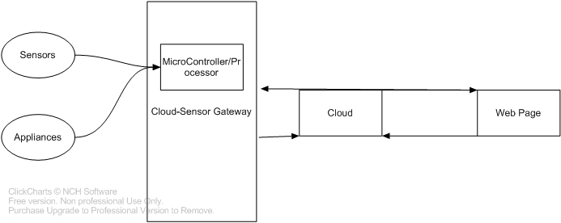

System Design with Cloud-Sensor Gateway integrated with Microcontroller

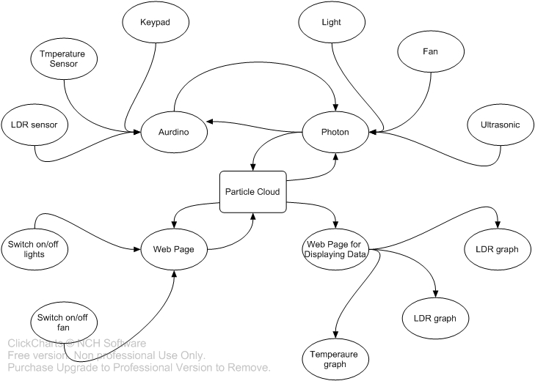

Connection of different subsystems

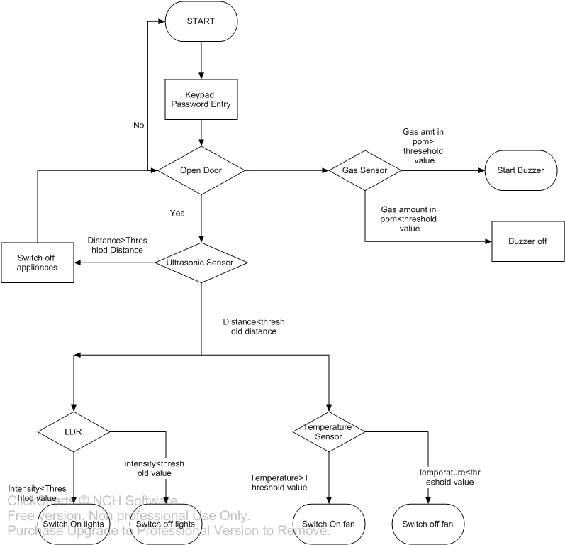

Functionality of Sensors/Appliances

The design process can be broadly classified into two different sections

1. Controlling the lights, fans, door and other appliances by sensing the surrounding with different sensor like PIR, ultrasonic, temperature sensor, LDR sensor,etc.
2. Sending and receiving data of sensors and appliances control over the cloud and controlling it through a web app.

For the first task, the different sensors connected are

1. Determining the temperature using LM35, which is a series are precision integrated-circuit temperature devices with an output voltage linearly proportional to the Centigrade temperature.
2. Detecting stationary movement using Ultrasonic ranging module HC - SR04 provides 2cm - 400cm non-contact measurement function, the ranging accuracy can reach to 3mm. The modules includes ultrasonic transmitters, receiver and control circuit
3. Detecting the amount of light using LDR Two cadmium sulphide(cds) photoconductive cells with spectral responses similar to that of the human eye
4. A piezo electric buzzer as an alarm
5. MQ06 gas sensor which is sensitive to LPG, iso-butane and iso-propane.

The entry to the house is through the door, which is controlled by entering the password in a keypad. If the password is correct, only then the door opens. Otherwise it stays closed.

The safety system includes gas and smoke detectors. When those sensors detect a value above a safe threshold limit, the piezo electric alarm is switched on.

The room has different sensors for automatically turning on the appliances when the presence is detected. The PIR sensor detects the motion and ultrasonic sensor detect stationary objects. These are placed at the entrance of the room, and when the ultrasonic sensor detects a person below a certain distance, the temperature of the room is processed and the fan is switched on if it is above a certain limit. The LDR sensor detects the light intensity in the room and if it falls below a minimum value, it switches the lights on.

The connection of system to the cloud includes connecting & exchanging system data and a means to control it. Conventionally, a gateway is needed to exchange sensor data over the cloud. This design directly publishes the sensor data to the cloud by using Particle photon which is synced with the particle cloud. Hence, by connecting the Arduino , which control the functionality of appliances , Particle Photon, by I2C, the data is directly published to the particle IO cloud. The data is published to the cloud using publish command, or publish a pin data as a function or a cloud variable. Each cloud function or variable has a URL and hence can be connected to a web app. The POST and GET commands can be used to either modify the variable data and hence pin status or display it on the monitor. Additionally, the appliances can be controlled through a web app, which is connected to the particle cloud.

A web page with buttons to switch ON/OFF light and fan allows operation of appliances over the internet. The sensors & appliances are monitored by graphs reading the real time values of the system.

**RESULTS/FINDINGS**

The Home Automation system was designed to reduce the communication channels between the sensors and the cloud. This was done using RaspberryPi and Particle Photon

1. All the sensors and appliances connected to the Raspberry Pi were connected to the IBM cloud only after RaspberryPi was explicitly made available via NodeJS. Sending and receiving of data required parsing at Cloud and RaspberryPi, which proved to be tedious.
2. The system sensors and appliances connected to the Particle Photon were published to the cloud instantly, without much network interfacing.

The System connected to the Particle Photon achieved the reduction of networking layer. This was possible due to the on-board IoT and cloud integration of the Particle.io network. This allowed feasible connection and disconnection of various nodes of the system.

Various results of the system connected to Particle Photon were

1. Different sensors were tested and their data was recorded and plotted.
2. The appliances were controlled using a secure web page over the internet
3. Exchange of data to and fro from sensors and cloud was monitored.

**CONCLUSION**

The primary objective of this project was to design a IoT based Home Automation system with less level of network layers between the sensors and cloud for better synchronisation of data, feasible up gradation of system, less power consumption and enhanced security. Though many gateways has been previously employed in IoT based Home Systems, we employed Particle Photon which has integrated cloud network, to our Home System, and connected sensor to cloud in a single step. This is the new knowledge. The new designed allowed monitoring and exchange of data in a simple and effective way. The system has limitation which can be worked on. More number of sensor and better functionality can be added on the component level. The system efficiency can be improved. New sensors can be designed with integrated cloud support.

**REFERENCE**

B. Selva Priya & R. Geethamani [2016].

DESIGN AND IMPLEMENTATION OF HOME AUTOMATION USING POWER ELECTRONIC SWITCHES

<http://www.ijaict.com/v2issue12/ijaict%202016041201.pdf>

Fei Ding, Aiguo Song, En Tong, and Jianqing Li

“A Smart Gateway Architecture for Improving Efficiency of Home Network Applications,” Journal of Sensors, vol. 2016.

N. Sriskanthan and Tan Karand.

“Bluetooth Based Home Automation System”. Journal of Microprocessors and Microsystems, Vol. 26, pp.281-289, 2002.

Shivani V Devoor, Syed Sha Qutub & Mallikarjuna Swamy M.S [2015].

Design of Sensor Network for Home Automation System

<http://www.ijeit.com/Vol%205/Issue%203/IJEIT1412201509_15.pdf>

Sirsath N. S, Dhole P. S, Mohire N. P, Naik S. C & Ratnaparkhi Vidyanagari

“Home Automation using Cloud Network and Mobile Devices”

<http://www.irdindia.in/journal_itsi/pdf/vol1_iss2/18.pdf>

Vinay sagar KN & Kusuma SM [2015].

“Home automation using internet of things”.

<http://www.irjet.net/archives/V2/i3/Irjet-v2i3317.pdf>

**APPENDIX**

1.

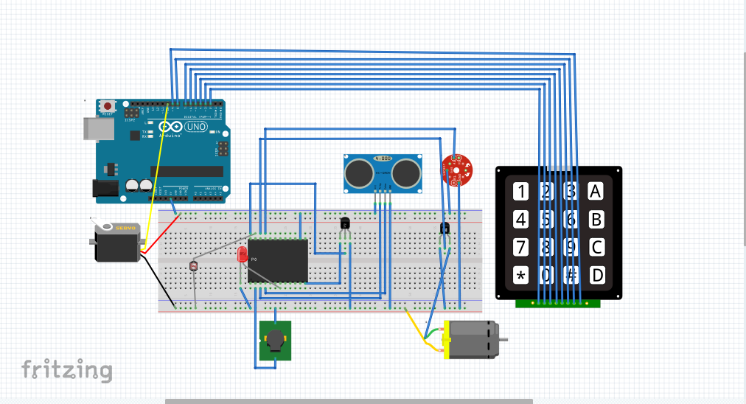

2.

3.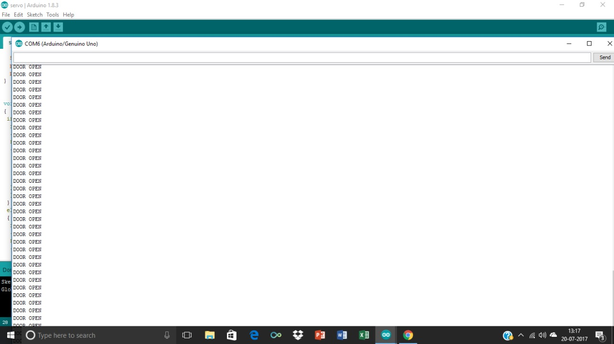

4.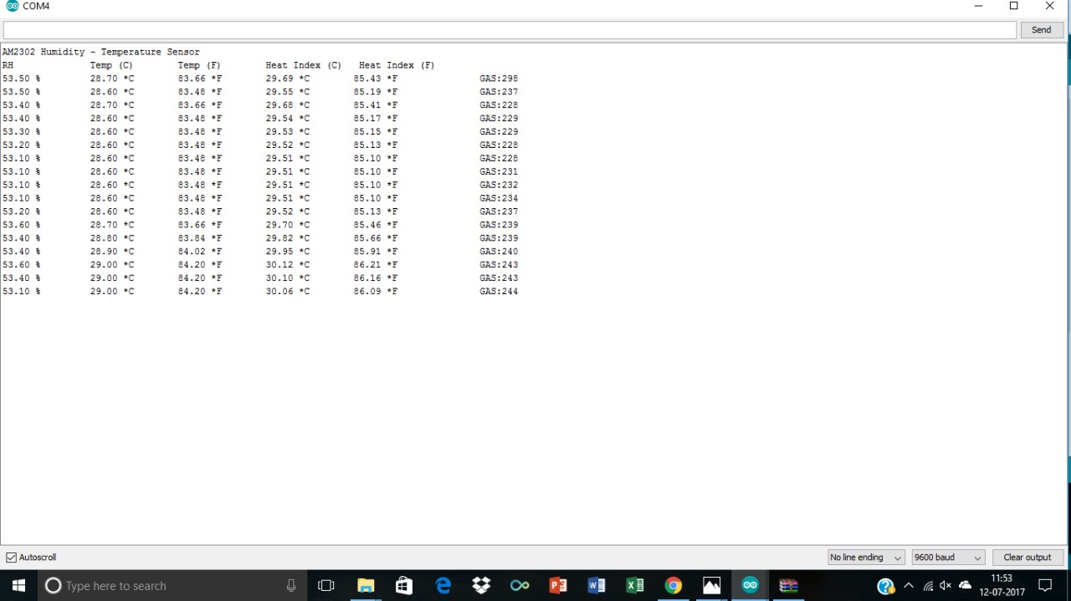

5.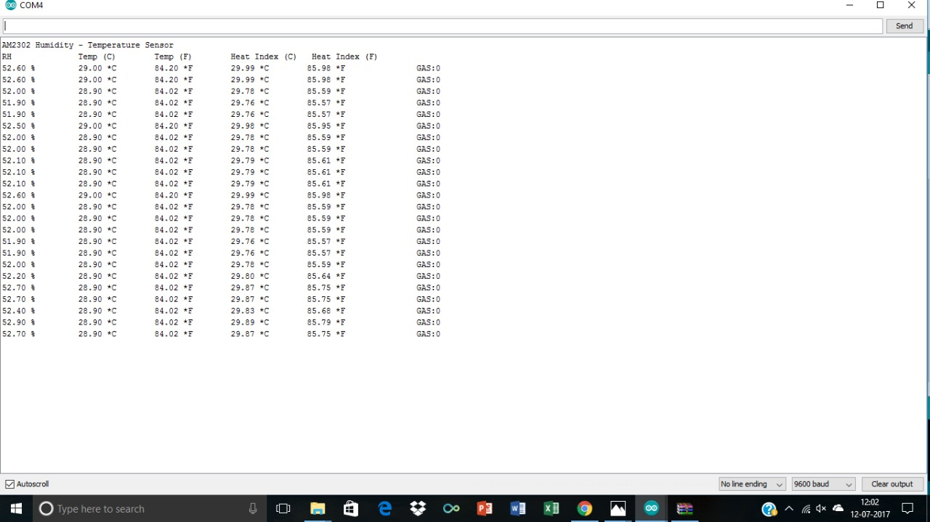

6.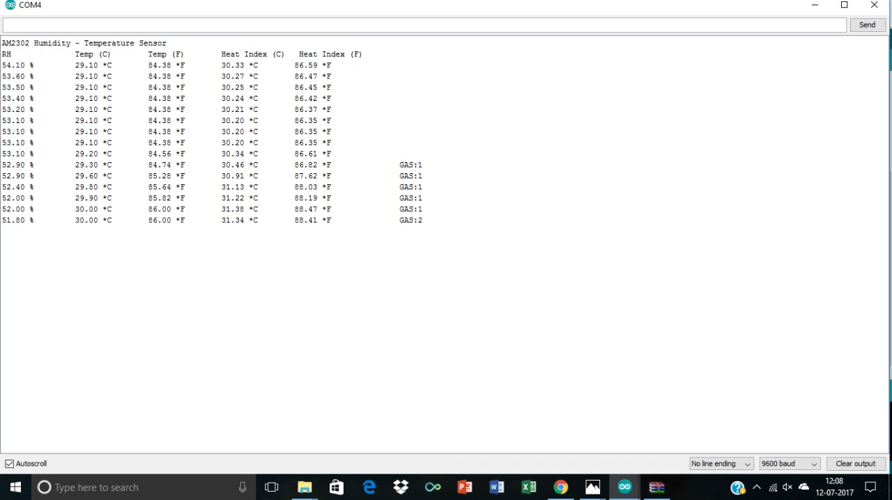

7.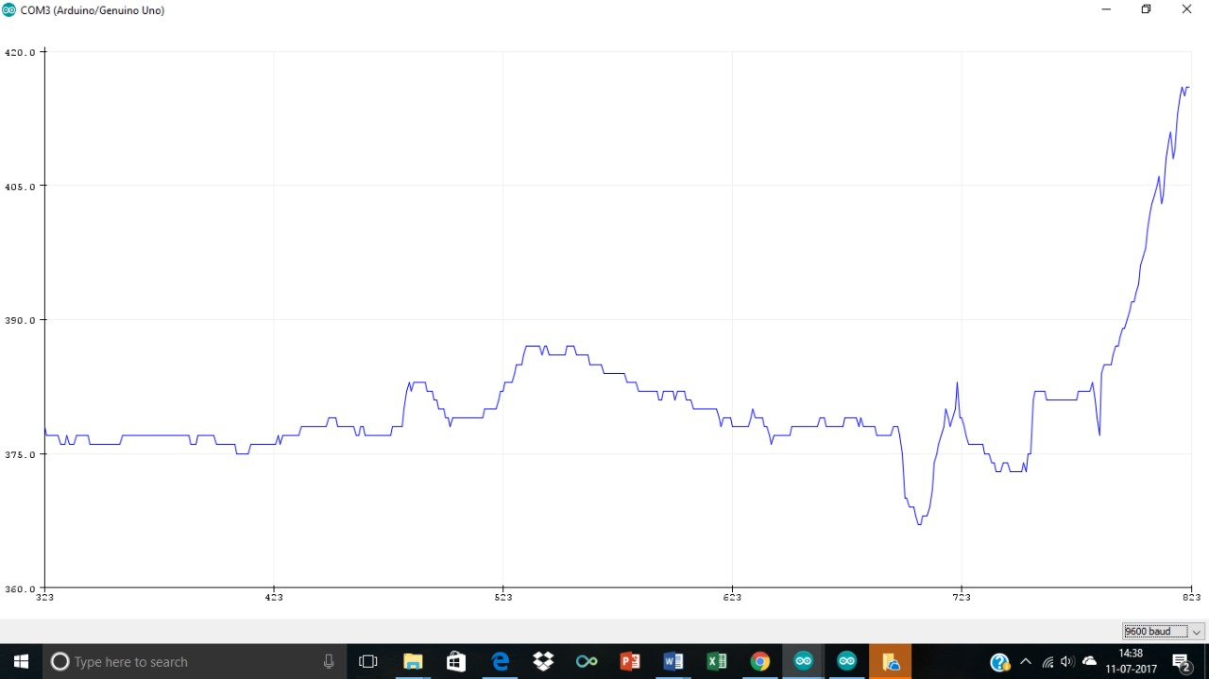

8.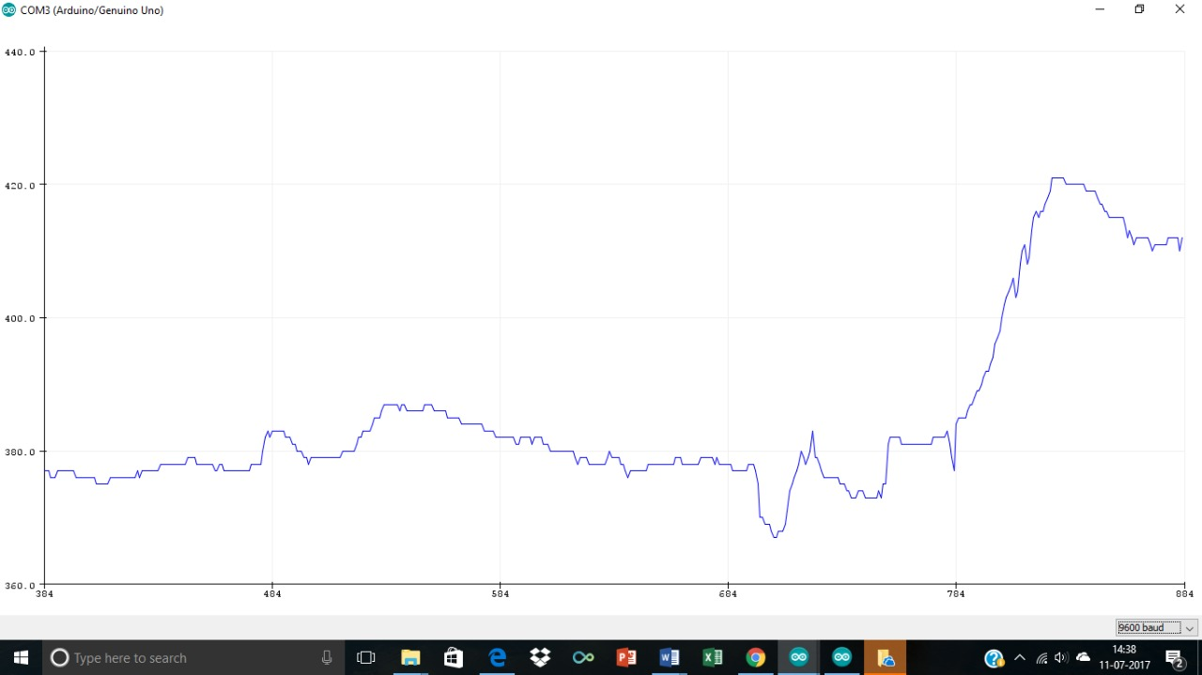

9.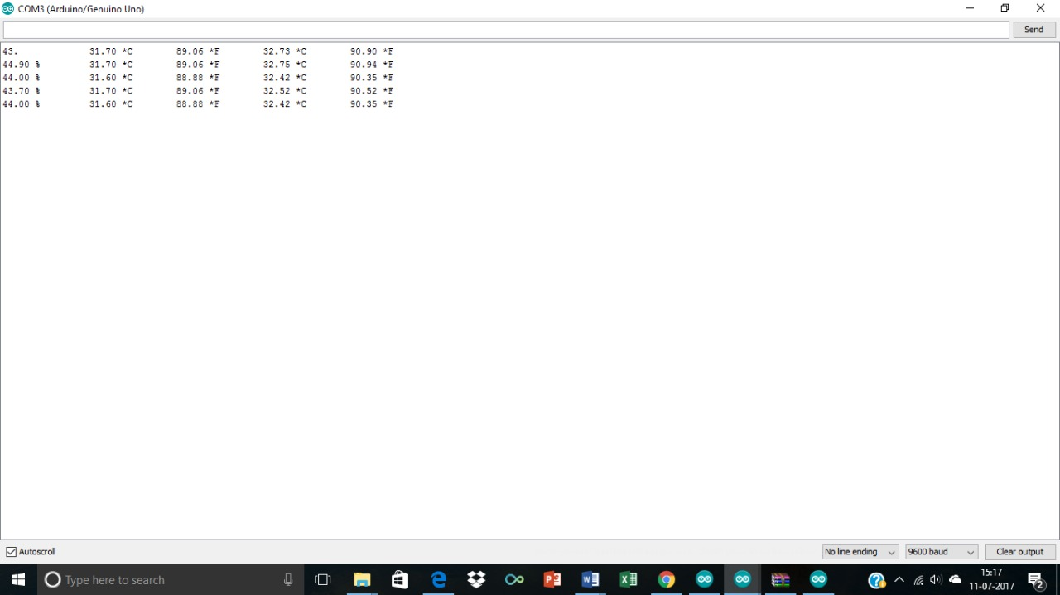

10.

11.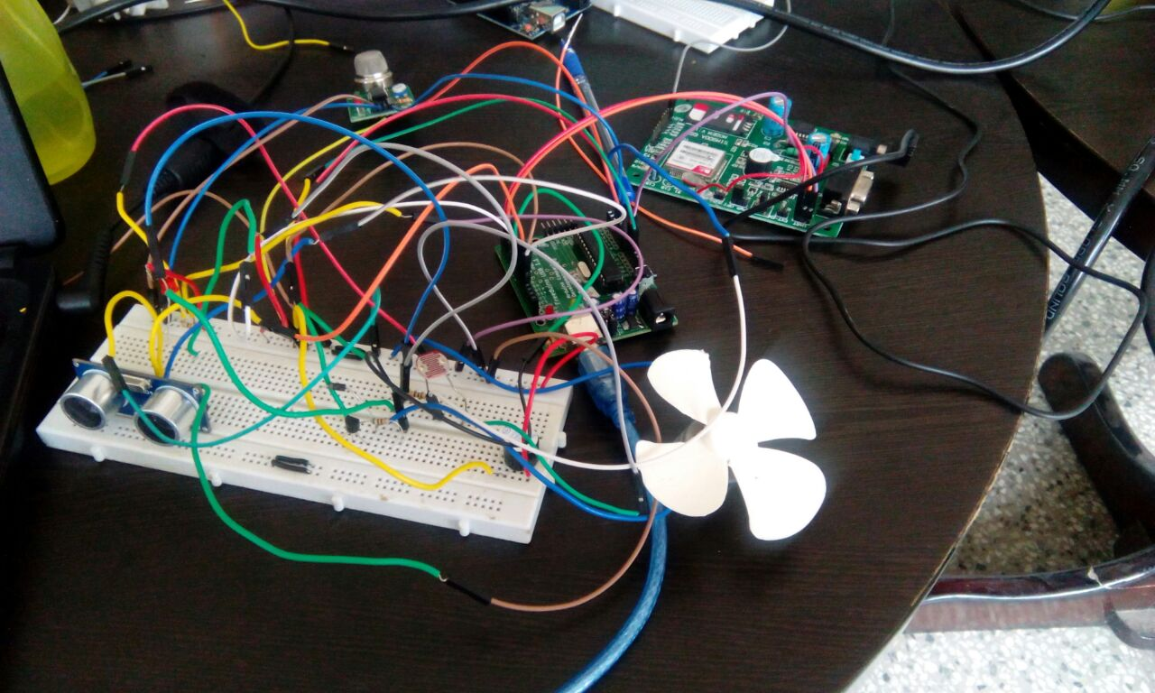

12.



13. 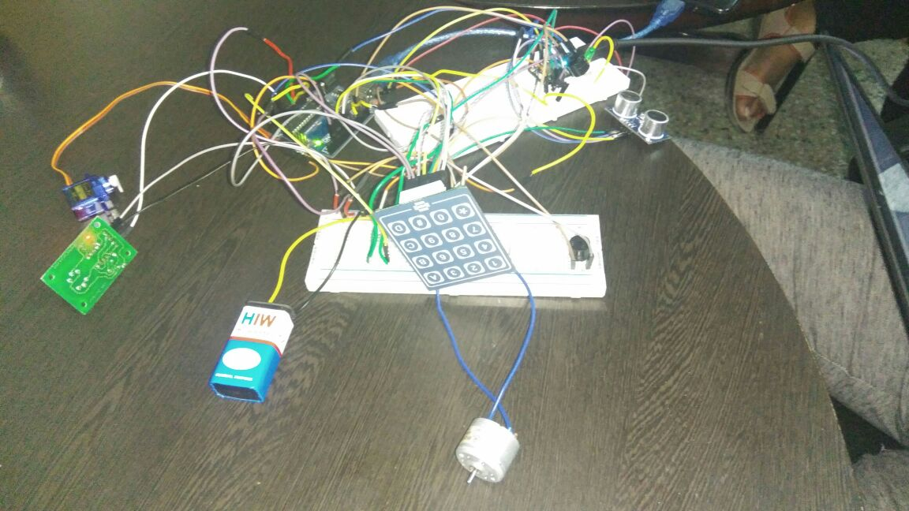

14.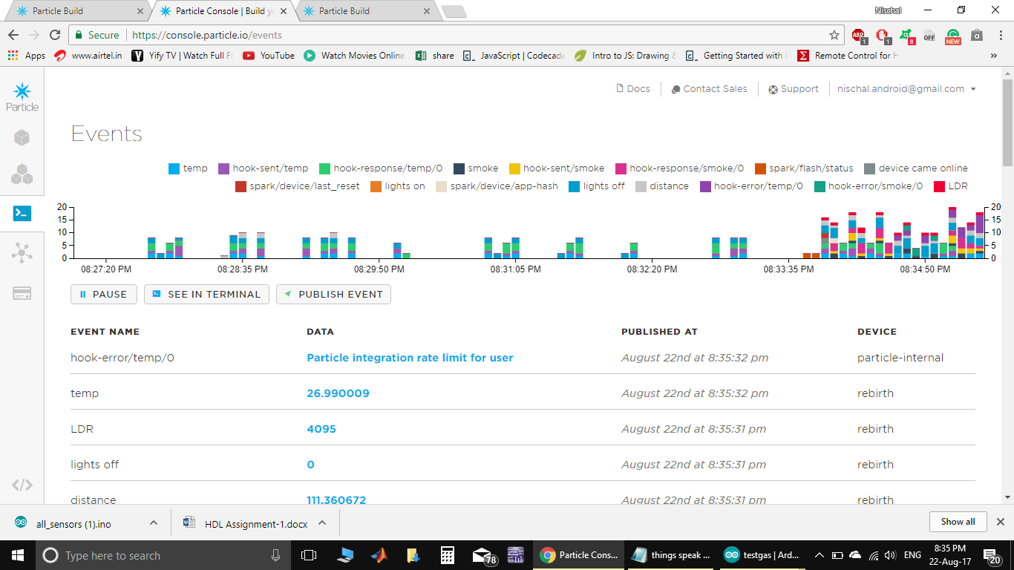

15.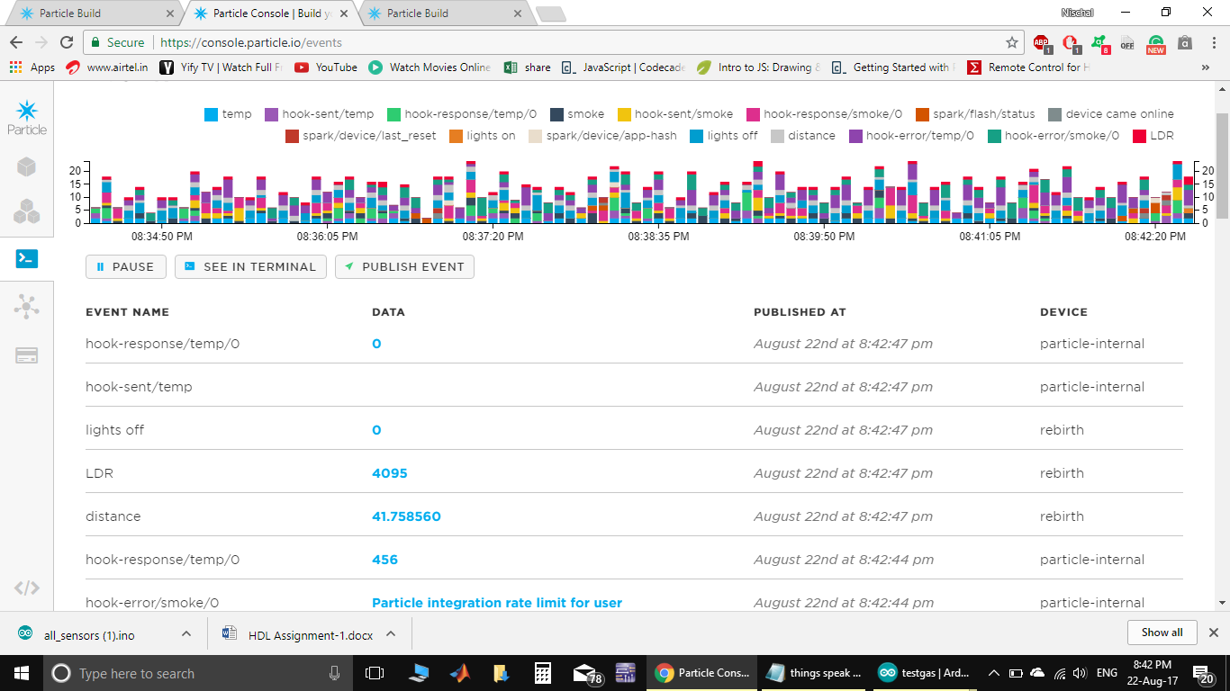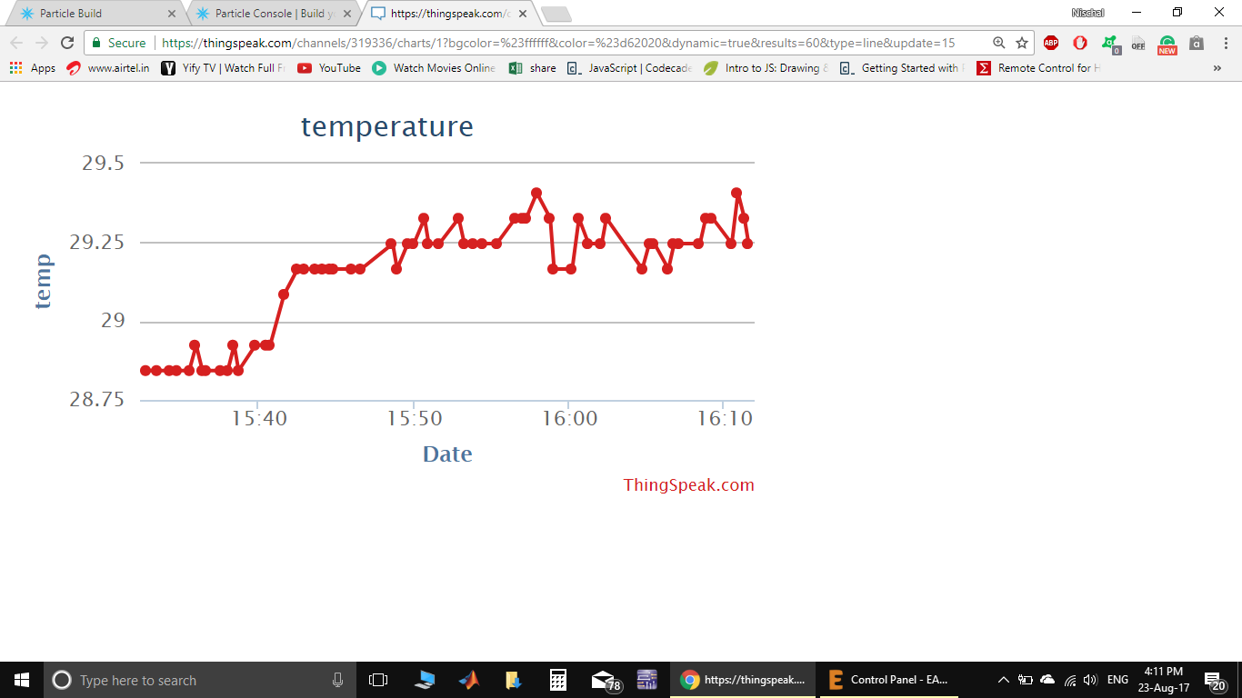

16.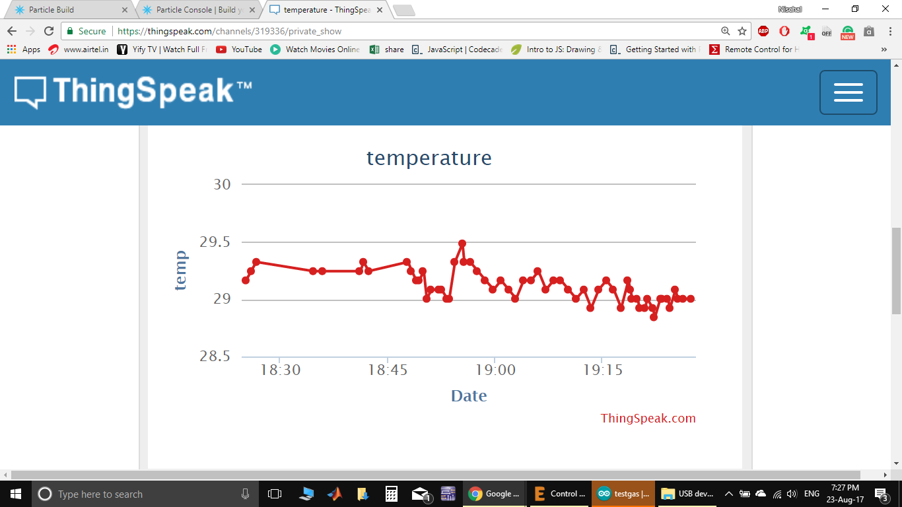

17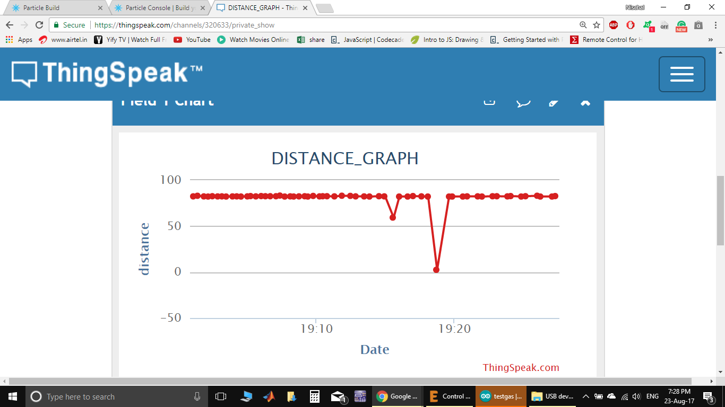

18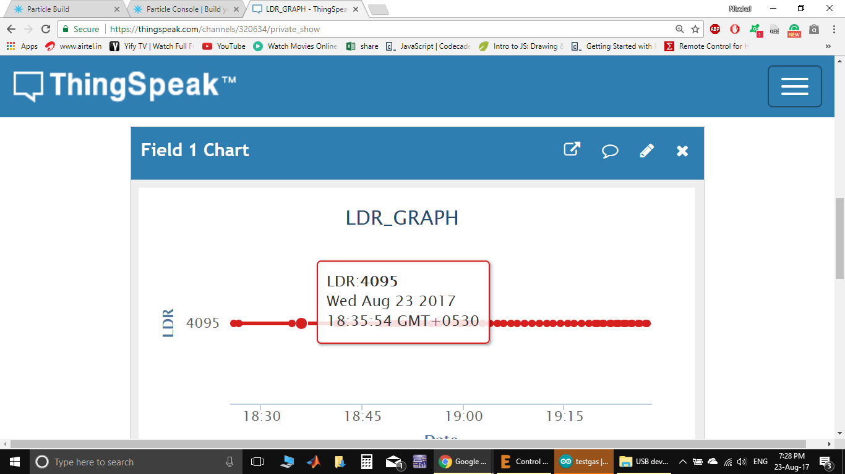

19. 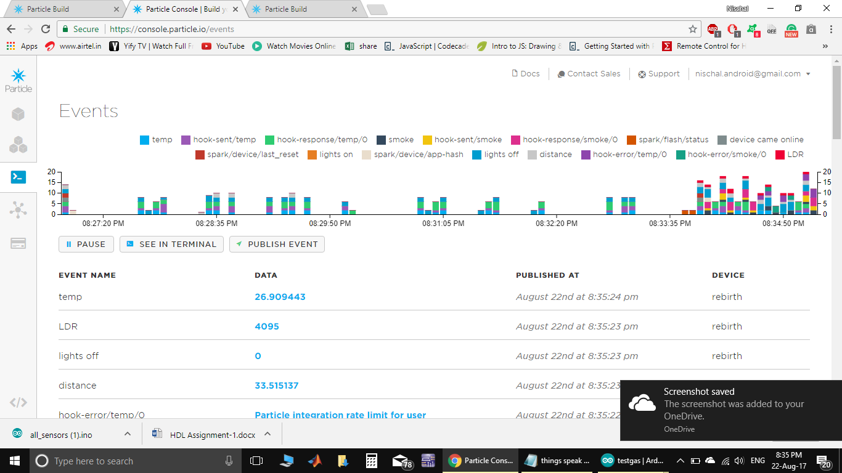

20. LM35 datasheet- <http://www.ti.com/lit/ds/symlink/lm35.pdf>

21. HCSR04 datasheet- [www.micropik.com/PDF/HCSR04.pdf](http://www.micropik.com/PDF/HCSR04.pdf)

22. MQ06 datasheet- <https://www.sparkfun.com/datasheets/Sensors/Biometric/MQ-6.pdf>

23. PIR datasheet- <https://www.mpja.com/download/31227sc.pdf>